# LINK DO GITHUB:

<https://github.com/britjea/Fiap-Apache-Camel-e-ActiveMQ>

Ambiente e Componentes de Desenvolvimento.

Criar duas aplicações usando apache camel e activemq



Integrantes

331883-Daniel Souza De Lima

330191- David Santos Vasconcelos

331429-Jean Pierre De Brito

330342-Luiz Felipe Moreira Do Amaral

# Sumário

LINK DO GITHUB: 0

Sumário 3

Criar duas aplicações usando apache camel e activemq 3

Fila Mq ActiveMQ 3

Classe Main 4

Classe impleRouteBuilder - PRODUCER 6

Enviando dados para a fila ActiveMQ Sheldon 7

Classe ReadQueue – Consomer 8

Lendo a fila Sheldon - ActiveMQ 9

# Criar duas aplicações usando apache camel e activemq

## Fila Mq ActiveMQ

Criei a fila MQ Sheldon para utilização na minha aplicação

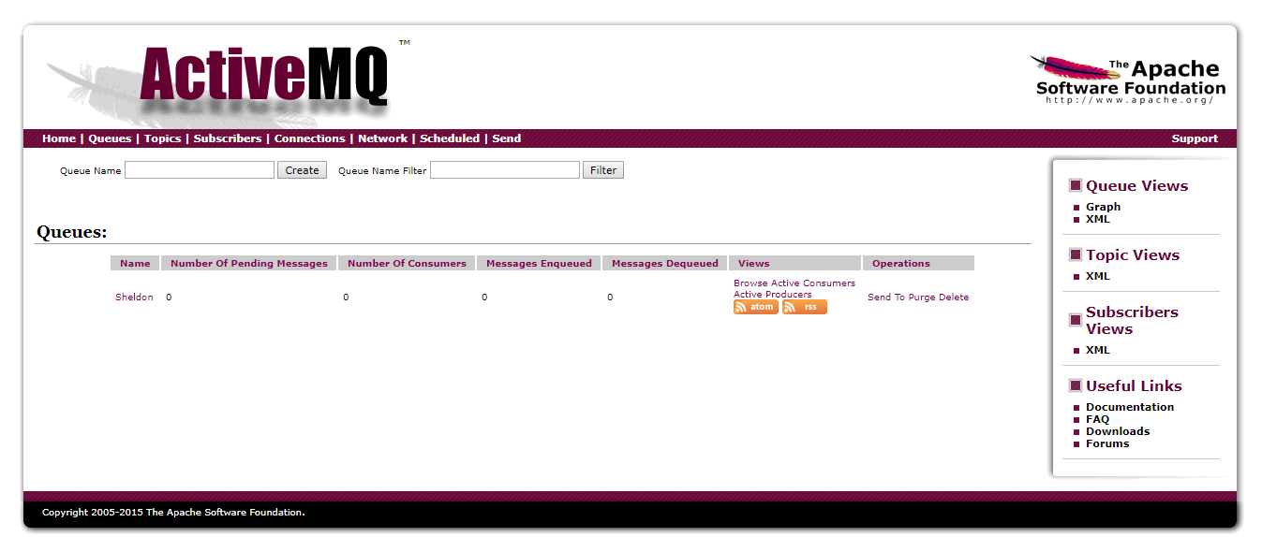

## Classe Main

Classe para criar a conexão com a fila Sheldo(ActiveMQ).

|  |
| --- |
| package br.com.fiap.main;  import javax.jms.ConnectionFactory;  import org.apache.activemq.ActiveMQConnectionFactory;  import org.apache.camel.CamelContext;  import org.apache.camel.component.jms.JmsComponent;  import org.apache.camel.impl.DefaultCamelContext;  import br.com.fiap.route.SimpleRouteBuilder;  public class MainApp {  public static void main(String[] args) {  // TODO Auto-generated method stub  SimpleRouteBuilder routeBuilder = new SimpleRouteBuilder();  CamelContext ctx = new DefaultCamelContext();    ConnectionFactory connectionFactory = new ActiveMQConnectionFactory("tcp://0.0.0.0:61616");    ctx.addComponent("jms",JmsComponent.jmsComponentAutoAcknowledge(connectionFactory));    try {  ctx.addRoutes(routeBuilder);  ctx.start();  Thread.sleep(5*60*100);  ctx.stop();  }  catch (Exception e) {  e.printStackTrace();  }    }  } |

## Classe impleRouteBuilder - PRODUCER

Busca os registro no diretório InpuArq para enviar para fila Sheldon criada o ActiveMQ

|  |
| --- |
| **package** br.com.fiap.route;  **import** org.apache.camel.builder.RouteBuilder;  **public** **class** SimpleRouteBuilder **extends** RouteBuilder{  @Override  **public** **void** configure() **throws** Exception{  from("file:\\C:\\InputArq").to("jms:queue:Sheldon");  }  } |

### Enviando dados para a fila ActiveMQ Sheldon

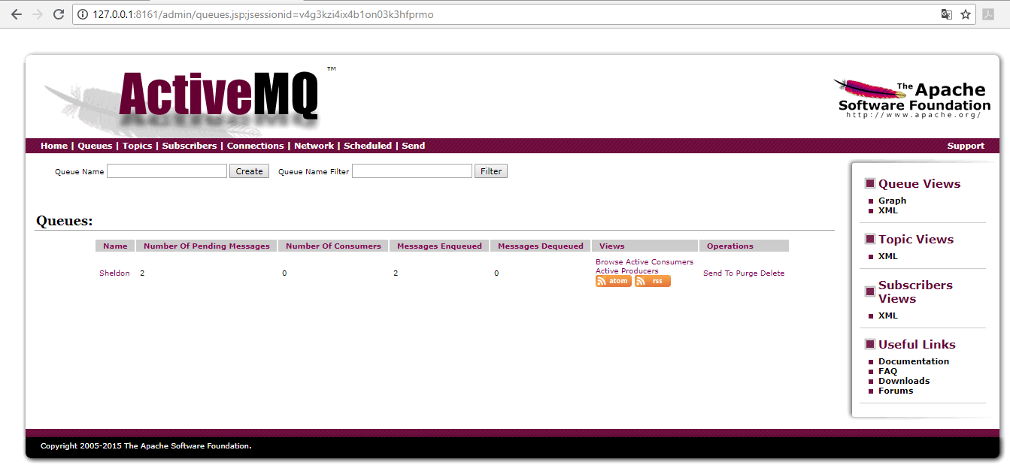

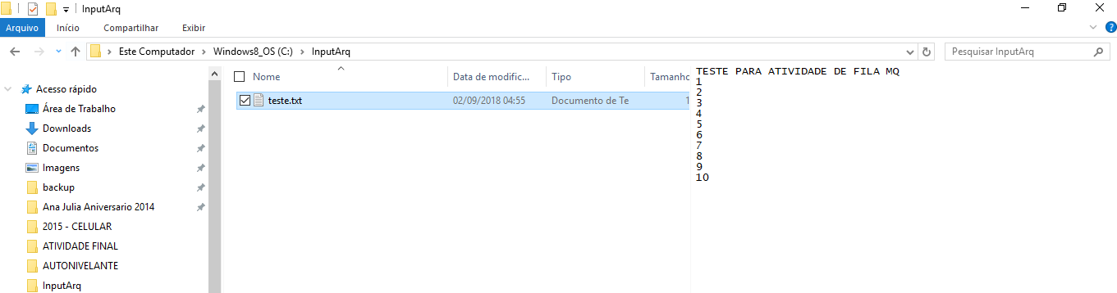

## Classe ReadQueue – Consomer

Classe para leitura da fila Sheldon(ACtiveMq) e guardando no diretório Output

|  |
| --- |
| package br.com.fiap.main;  import javax.jms.ConnectionFactory;  import org.apache.activemq.ActiveMQConnectionFactory;  import org.apache.camel.CamelContext;  import org.apache.camel.builder.RouteBuilder;  import org.apache.camel.component.jms.JmsComponent;  import org.apache.camel.impl.DefaultCamelContext;  public class ReadQueue {  public static void main(String[] args) throws Exception {  // TODO Auto-generated method stub  CamelContext ctx = new DefaultCamelContext();  ConnectionFactory connectionFactory = new ActiveMQConnectionFactory("tcp://0.0.0.0:61616");    ctx.addComponent("jms",JmsComponent.jmsComponentAutoAcknowledge(connectionFactory));    ctx.addRoutes(new RouteBuilder() {  public void configure () {  from("jms:Sheldon")  .to("stream:out")  .to("file:\\C:\\Output");  }  });    ctx.start();  Thread.sleep(100000);  ctx.stop();  }    } |

### Lendo a fila Sheldon - ActiveMQ

